**Advance Pattern Reference Guide**

**ABCD Pattern**

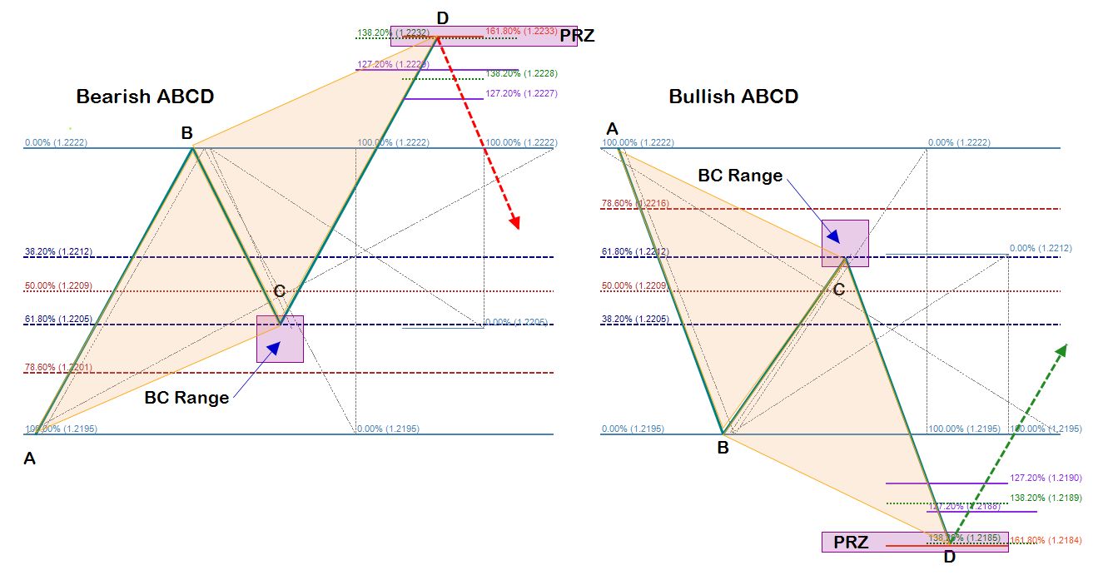

**Gartley Pattern**

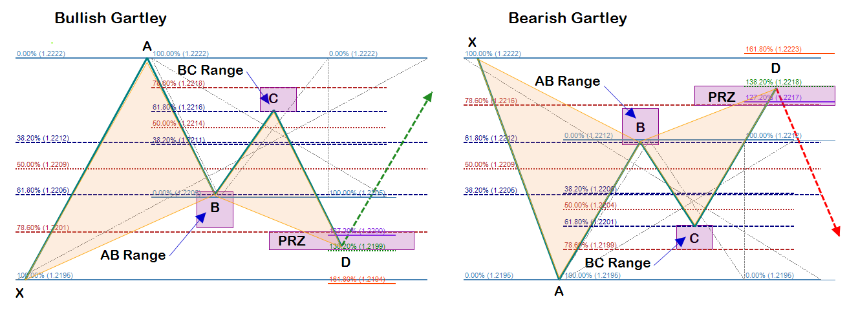

**Butterfly Pattern**

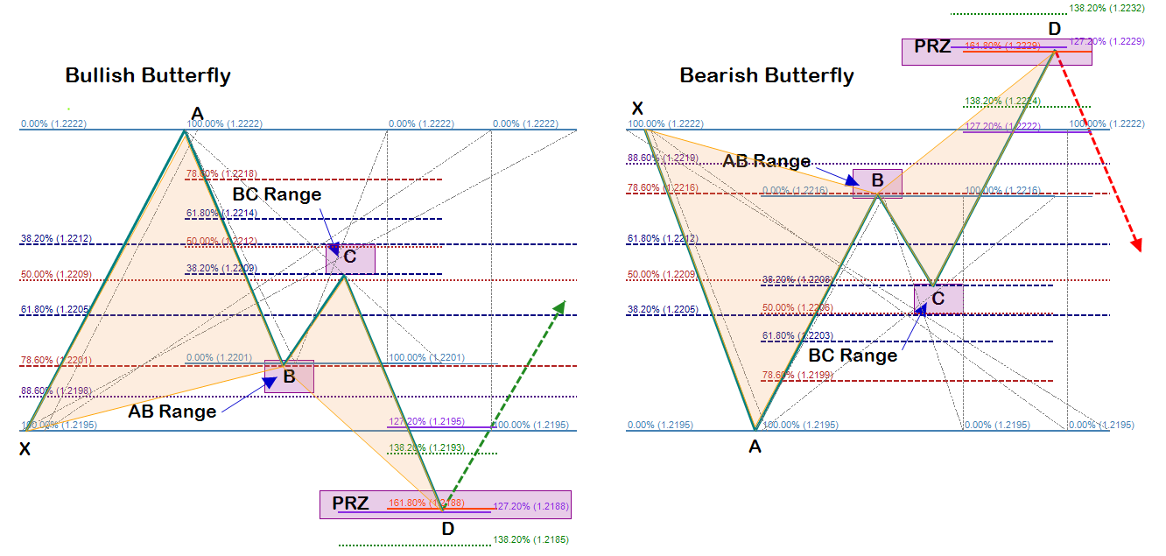

**Bat Pattern**

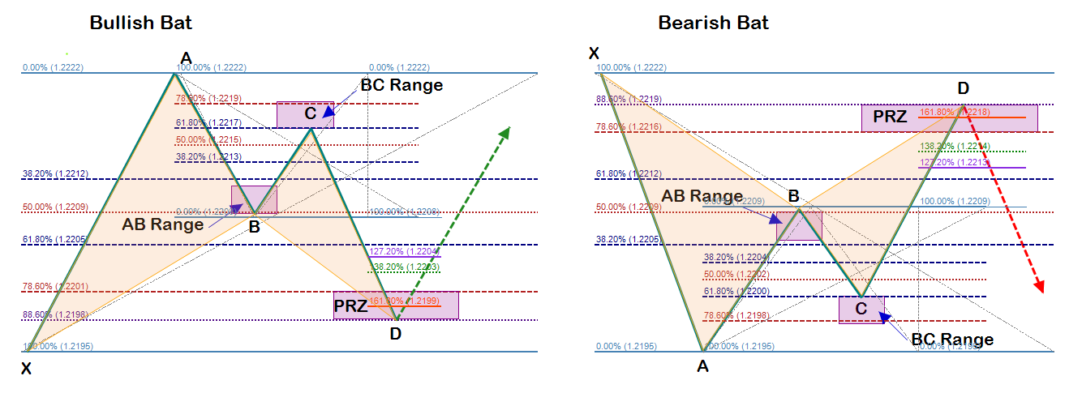

**Crab Pattern**

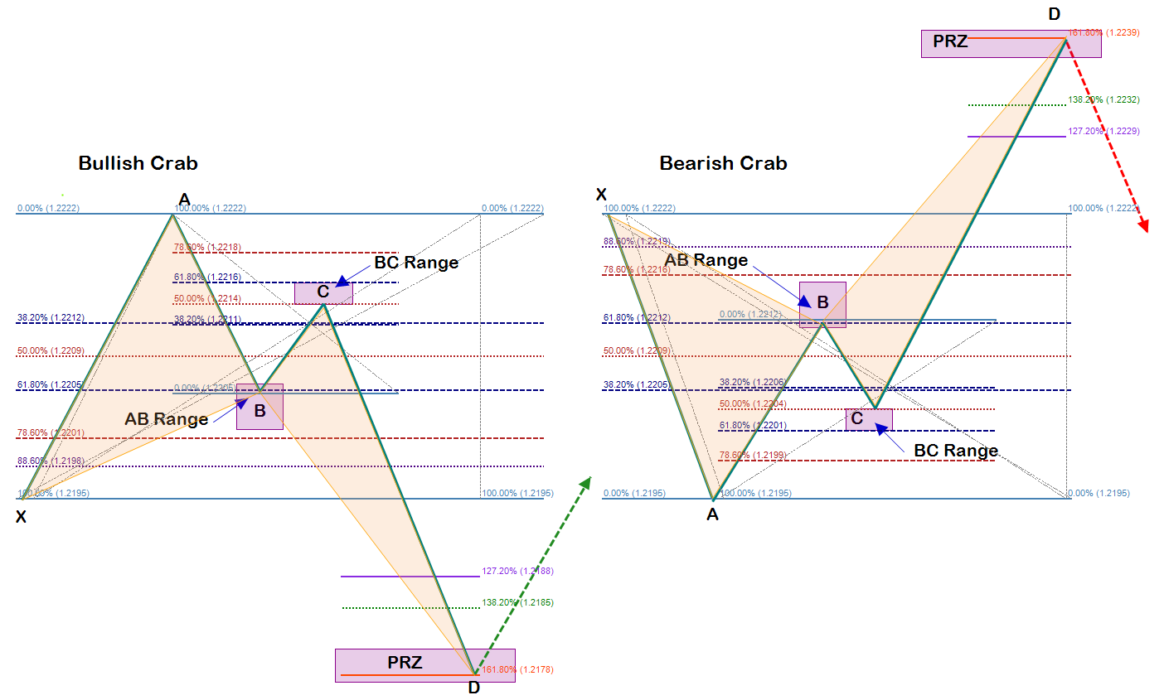

**Fibonacci Sequence Numbers: 8, 13, 21, 34, 55, 89, 144**

**Note:**

**These advance patterns have ratio modifications that have been optimized to produce the highest quality trading signals under the scope of the trading strategies of DCASTFX. Each pattern has a specific set of criteria that must be met prior to the consideration of taking a position. This guide is designed to be used as a visual reference tool and taking trades off of this guide without understanding the criteria involved is reckless and hazardous to your account.**